*Simple Linear Regression*

|  |  |
| --- | --- |
| Cgpa | Package |
| 9 | 8 |
| 8.9 | 90LPA |
|  |  |
|  |  |
|  |  |

1. Data ko Plot karo
2. X axis pe CGPA & Y axis pe package
3. Kindoff of Linear hai yeah data

*Real World Data == Effected by Real World Factors.*

*Jo Error ko determine nahi karsakte ushe hum Stochastic Error kehte hai*

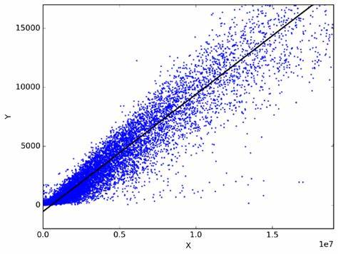

*Y = mx + b*

*y &x = variables*

*m = slope ( jaha se line draw horahi hai )*

*b = y-intercept (jahase line draw horhi udr se end tak )*

*x represent cgpa & y represent krrha package kitna hoga.*

*As humko pata hai humara data kindoff linear hai…*

*Abh hum kya karenge basically ki firbhi 1 Line Draw Karenge*

*& vo jo Line hai vo* ***Best Fit Line*** *Kehlata hai..*

*Why Best Fit Line Coz yeah Line Minimum galti karta hai*

*Perfect line vo hota hai jo har data se pass hoo but as data is not much proper Perfect Line plot nahi karpaate so that’s why Linear regression 1 Best Fit Line hummedeta hai.*

*Qs. Pehle data check kro ki data linear hai ki nahi*

*Linear Regression kya karta hai ki 1 Line kheechta hai jo ki minimum galti kareah iska mtlb ki har Data point se closest pass kareah*

*How to Find m & b*



*0 0 🡪 m*

*01 ->b*

*J -> loss function or error function*

*Humme esa m & b ka value chaye jahape Error Function ka jo value hai vo Minimum hoo*

*Minima -> jbh minimum pe hai tbh slope 0 hoga*

*& slope nikalnekeliye derivative nikalke Zero karna padega*

*Partial Derivative use krna hoga*

*Maxima ->*

*Ek Error Function ke Equation ko Zero ke equal krdo*

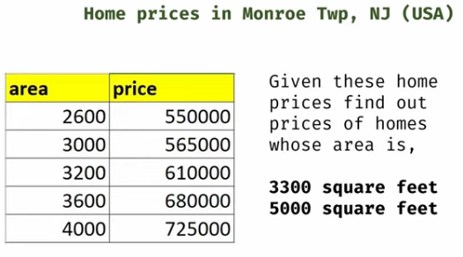

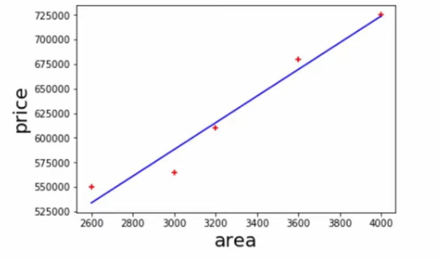

Yeah Blue Line Draw Kaise kreah ???

**Pehle 1 Random Line Draw karo then**

**Line & Points ka Distance find karo basically just a eucliden distance hai aur kchnahi**

**Uskebaad sbh delta ka Square krdo (coz negative na hoo +ve hie hoo) & then saare number ka Sum karo Yeahi hai == MSE ( Mean Squared Error )**

**Yeahi Error Sbhse zyaada kamm jissline mai hai vahi Best Fit Line hai**

